University of Naples Federico II
Polytechnic and Basic Sciences School
Department of Industrial Engineering
Master’s Degree in Autonomous Vehicle Engineering
Master’s Degree Class LM-33



Master’s Degree Thesis on
Preliminary Design of XXXXXXXX (Thesis title)

Supervisor:
Prof. XXXXXXXX
Co-Supervisor:
Dott. Yyyyy. XXXXXXXXXXX
Candidate:
XXXXXXXXXXXXXX
P44/XXXXXXXX

ACADEMIC YEAR 2022-2023
Table of Contents

Nomenclature ii
Introduction 1
1. Sustainable mobility as a necessity (Chapter) 3
1.1 Issues related to oil-based road transport (Paragraph) 3
1.1.1 Details (Subparagraph) 3
Acknowledgements 5
References 6

Nomenclature
ICE  GHG  EU  BEV  FCEV  HEV | Internal Combustion Engine  Greenhouse Gas  European Union  Battery Electric Vehicle  Fuel Cell Electric Vehicle  Hybrid Electric Vehicle

Introduction
Nowadays, the critical environmental context and economic crisis require means of transport more efficient and less polluting than those currently used, which are petroleum-dependent [Chu, 2012].
Electrification of road vehicles appears as the best way to reduce the dependency from fossil fuels [Ehsani, 2009], but many limits of existing technologies reduce market penetration of these electric/hybrid vehicles.
An electric/hybrid powertrain is a complex system: a large number of variables get the process of design definition for a powertrain quite complicated. For this this reason, the process of designing and engineering of a power-train can conveniently be included in the context of Systems Engineering (SE). The interdisciplinary field of SE is focused on how designing and managing complex systems over their life cycle [Linden, 2001]. SE proposes a structured approach and a series of methods to coordinate all the interdisciplinary tasks that are required to transform customer needs, requirements, and constraints into a real system solution.
In this manuscript, a study is carried out to evaluate some different design solutions for the electrification/hybridization of a mini-bus for urban use. Two applications of this mini-bus are considered: a general urban use and a specific route on the island of Capri.

Sustainable mobility as a necessity (Chapter)
During the last decades, a growing concern over the problems associated with fossil-fueled vehicles as well as the sustainability of the current worldwide petroleum-based transport has emerged [1]. As a consequence, the interest in propulsion systems for road transport alternative to the actual petroleum-based has increased. In this chapter, these problems are outlined and some feasible solutions, allowed by the existing technology, are presented.

Issues related to oil-based road transport (Paragraph)

Details (Subparagraph)
Vehicles powered by internal combustion engine (ICE) emit many pollutants, including carbon monoxide (CO), particulate matter (PM - especially diesel engines), oxides of nitrogen (NO_{x}), sulphur dioxide (SO₂), volatile organic compounds (VOCs), and various other hazardous air pollutants including benzene [Wakefield, 1998]. All these substances are toxic for human health, and road transport is a significant contributor to their concentration, as appear in Figure 1.1 [Veneri, 2012]. Considering only urban areas, road transport is considered the major contributor to pollutants concentrations [Schupbach, 2002].

Figure 1.1 - Emissions, by sector, of main air pollutants in Europe
Traditional vehicles are also considerable emitters of carbon dioxide, which is non-toxic to humans, but is the main greenhouse gas (GHG). GHGs are the principal cause of the well-known problem of global warming.

Table 1.1 - Example table caption
A | B | C
1 | 2 | 3

Acknowledgements
I would like to thank …

References
[1] | Chu, S., Majumdar, A. , 2012 Opportunities and challenges for a sustainable energy future. Nature, vol. 488, n. 7411, pp. 294-303.
[2] | Ehsani, M. , Gao, Y. Emadi, A., 2009 Modern electric, hybrid electric, and fuel cell vehicles: fundamentals, theory, and design. CRC press.
[3] | Linden, T. R. D., 2001, Handbook of Batteries, McGraw-Hill.
[4] | Wakefield, E. H., 1998. History of the Electric Automobile-Hybrid Electric Vehicles, vol. 187.
[5] | Veneri, O., Migliardini, F., Capasso, C., Corbo, P., 2012. ZEBRA battery based propulsion system for urban bus applications: Preliminary laboratory tests. Proc. Of Electrical Systems for Aircraft, Railway and Ship Propulsion (ESARS).
[6] | Schupbach, R. Balda, J., 2002. A versatile laboratory test bench for developing powertrains of electric vehicles. Proc .of Vehicular Technology Conference,. 2002 IEEE 56th, 2002.

Appendix A
Because of the deformation of the tyre body, the motion of the wheel is not of pure rolling.
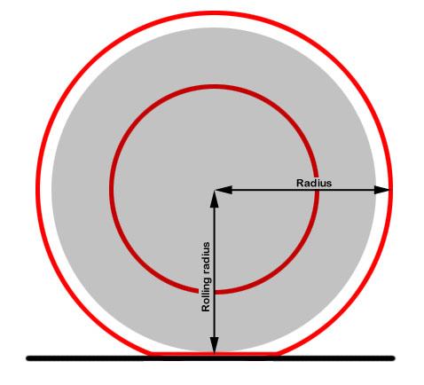
We can consider it as a pure rolling motion if adopt a smaller radius known as pure rolling radius, defined as:
$r=\frac{V}{ω}$ (1)
where V is forward velocity of wheel centre, $ω$ is its angular velocity.
This effective radius can be determined as:
$R_{e}=R_{g}-f_{s}$ (2)
where $R_{g}$is the geometric radius, $f_{s}$ the static deflection of the tyre.

